Attachment to contract terms for Phase 3, Guarantee
- Template

EFFECT4buildings Toolbox:
Energy Performance Contracting; Annex 9

The project “Effective Financing Tools for implementing Energy Efficiency in Buildings” (EFFECT4buildings) develops in collaboration with public building managers a comprehensive decision-making support toolbox with a set of financial instruments: Financial calculation tools; Bundling; Funding; Convincing decision makers; Energy Performance Contracting; Multi Service Contracting; Green Lease Contracting; Prosumerism. The tools and instruments chosen by the project has the biggest potential to help building managers to overcome financial barriers, based on nearly 40 interviews with the target group. The project improves these tools through different real cases.
To make sure building managers invest in the best available solutions, more knowledge on different possibilities is needed as well as confirmation from colleagues that the solutions performs well. EFFECT4buildings mapped technological solutions for energy efficiency in buildings with the aim to share knowledge and experiences of energy efficiency solutions among building managers in the Baltic Sea Region.

Energy Performance Contracting (EPC) is a well-tested and successful model for energy saving. It is used by public building owners to reach climate and energy targets at a faster pace than with traditional implementation. There is still a large energy-saving potential in public sector.

This template is an attachment to contract terms for Phase 3, Guarantee based on the Guide to EPC developed in the framework of the EFFECT4buildigs project. The guide introduces a new implementation model based on experiences in the countries involved in the EFFECT4buildings project - its main novelty aspects being contract based partnership during the analyses phase and new award criteria to better fit the goals of building owners.
The Attachment to contract terms for Phase 3, Guarantee is part of a toolbox of 9 documents and templates adapted to the new implementation models various phases primarily emphasising the first two phases. Experiences from past EPC projects shows that decisions made early are crucial. The goal is to promote EPC as an energy saving model and simplify the start-up of an EPC project.
Below is a schematic overview of the adapted tools and instruments for EPC:
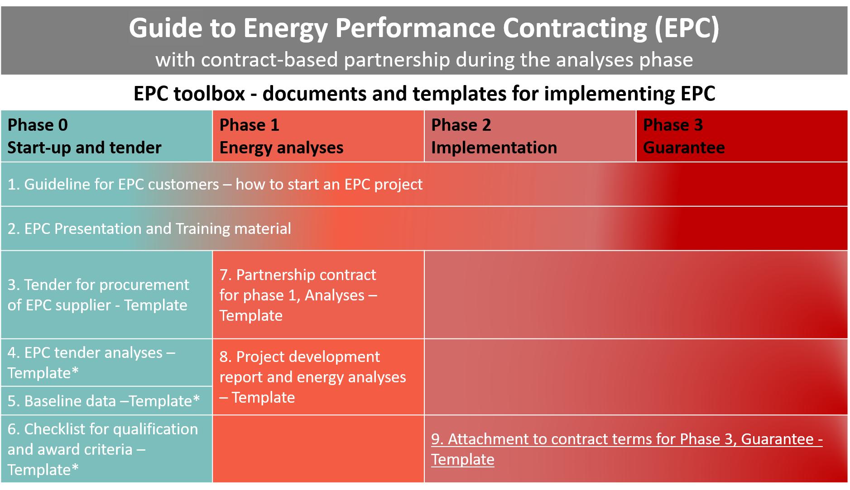
*Not considerably altered compared to traditional EPC implementation model documents

How to use the template
- This template is part of EPC offer.
- This document is intended as an attachment to the Phase 3 contract and should be completed at the end of Phase 1.
- The document refers to the official [Norwegian EPC standard; NS 6430 Chapter 7 "Contract terms in the savings guarantee phase".]
- In the margins you might find important information to users with background information and advice on what sections should be thoroughly checked and adapted to national laws, regulations, and specific project conditions.
- Please make sure all introductory text, texts in the margins and logos and layout are deleted before launching it as an attachment to the EPC tender.

The EFFECT4buildings project is implemented with the support from the EU funding Programme Interreg Baltic Sea Region (European Regional Development Fund) and Norwegian national funding. The aim of the project is to improve the capacity of public building managers in the Baltic Sea Region by providing them with a comprehensive decision-making support toolbox with a set of financial instruments to unlock the investments and lower the risks of implementing energy efficiency measures in buildings owned by public stakeholders. More information: http://www.effect4buildings.se/
Partners

Key elements and content of a contract for phase 3:
(Content based on the official [Norwegian EPC standard; NS 6430 Chapter 7 "Contract terms in the savings guarantee phase".]

- The obligations of the energy service company (ESCO)
    - The duration of the agreement period
    - Implementation of measures and control
    - Cooperation duty
    - Reporting and energy monitoring
- The obligations of the client (building owner)
    - Operation, supervision, maintenance and service
    - Changes in the contract subject
    - Payment (e.g. yearly fee)
- Risk of hidden errors and shortcomings
- Replacement parts
- Access to the contract subject
- Technical documentation
- Saving guarantee
- Determination of the saving guarantee (based on agreed method of settlement)
- Payment defaults
- Termination

Background

This document is intended as an attachment to the Phase 3 contract and should be completed at the end of Phase 1.
The document contains examples of a contract layout and refers to the official [Norwegian EPC standard; NS 6430 Chapter 7 "Contract terms in the savings guarantee phase".]

This document is intended as an attachment to the Phase 3 contract and should be completed at the end of Phase 1.
The document contains examples of a contract layout and refers to the official [Norwegian EPC standard; NS 6430 Chapter 7 "Contract terms in the savings guarantee phase".]

The obligations of the energy service company (ESCO)

Implementation of measures and control
An operating instruction must be prepared for each building, which includes all relevant facilities in the building. This also applies to installations for which no action has been taken.
This instruction must contain:
- Contact persons at the energy contractor
- Routines for daily supervision
- Routines for maintenance
- Overview of service agreements
- Airflow, operating times and set temperatures of ventilation systems (before and after implemented measures)
- Daytime temperatures and lowering temperatures for heating systems (before and after implemented measures)
- Set points for snowmelt
- etc.

Date delivered to the client
Operating and maintenance instructions have been prepared and delivered to the client
Plan for training is prepared, delivered and approved

The obligations of the client

Operation, supervision, maintenance, and service
Template for journal of operations, as well as the client's own maintenance:
A custom and unified journal template must be prepared, which corresponds to the energy contractor's operating and maintenance instructions.

Changes in the subject-matter of the contract
The client must inform about any changes that have a significant impact on the energy saving guarantee. This may be a change in operating times and or replacement of technical equipment. The changes must be notified in advance and the contractor must calculate how much this represents for the savings guarantee (both in the positive and in the negative direction). The client shall approve this calculation.
A template for how this is calculated will be developed. This will be called "Template for Modification of Contract Object» and should be attached to the Phase 3 contract. This template should include:
- Name and number of building and construction
- Type of installation
- Description of change
- Time for change to take effect
- Change in kWh / year and in EUR / year (calculated by the contractor and approved by the client)

