Project development report and energy analyses
- Template

EFFECT4buildings Toolbox:
Energy Performance Contracting; Annex 8

The project “Effective Financing Tools for implementing Energy Efficiency in Buildings” (EFFECT4buildings) develops in collaboration with public building managers a comprehensive decision-making support toolbox with a set of financial instruments: Financial calculation tools; Bundling; Funding; Convincing decision makers; Energy Performance Contracting; Multi Service Contracting; Green Lease Contracting; Prosumerism. The tools and instruments chosen by the project has the biggest potential to help building managers to overcome financial barriers, based on nearly 40 interviews with the target group. The project improves these tools through different real cases.
To make sure building managers invest in the best available solutions, more knowledge on different possibilities is needed as well as confirmation from colleagues that the solutions performs well. EFFECT4buildings mapped technological solutions for energy efficiency in buildings with the aim to share knowledge and experiences of energy efficiency solutions among building managers in the Baltic Sea Region.

Energy Performance Contracting (EPC) is a well-tested and successful model for energy saving. It is used by public building owners to reach climate and energy targets at a faster pace than with traditional implementation. There is still a large energy-saving potential in public sector.

This template for EPC project development report and energy analyses is based on the Guide to EPC developed in the framework of the EFFECT4buildigs project. The guide introduces a new implementation model based on experiences in the countries involved in the EFFECT4buildings project. Its main novelty aspects being contract based partnership during the analyses phase and new award criteria to better fit the goals of building owners.
The Project development report and energy analyses is part of a toolbox with 9 documents and templates adapted to the new implementation models various phases primarily emphasising the first two phases. Experiences from past EPC projects shows that decisions made early are crucial. The goal is to promote EPC as an energy saving model and simplify the start-up of an EPC project.
Below is a schematic overview of the adapted tools and instruments for EPC:
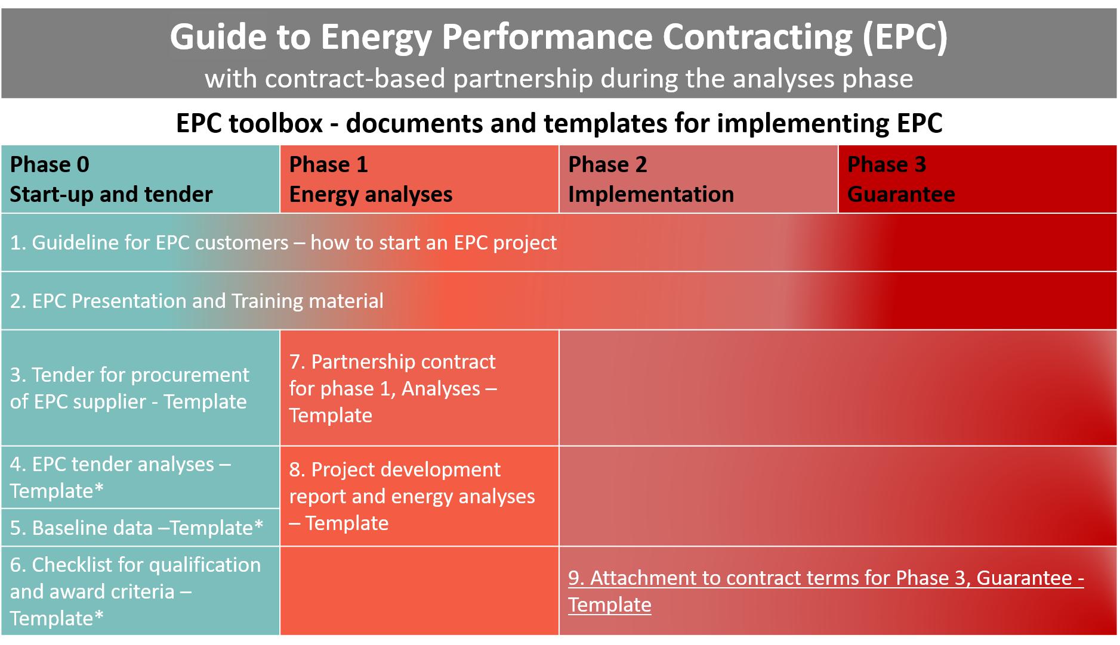
* Not considerably altered compared to traditional EPC implementation model documents

How to use the template
- This document is based on a Norwegian template for EPC project development report and energy analyses and adapted for changes in the new implementation model for EPC with contract-based partnership in phase 1.
- In the margins there are important information to users with background information and advice on what sections should be thoroughly checked and adapted to national laws, regulations, and specific project conditions.
- Please make sure all introductory text, texts in the margins and logos and layout are deleted before launching the EPC tender.
EFFECT4buildings project is implemented with the support from the EU funding Programme Interreg Baltic Sea Region (European Regional Development Fund) and Norwegian national funding. The aim of the project is to improve the capacity of public building managers in the Baltic Sea Region by providing them a comprehensive decision-making support toolbox with a set of financial instruments to unlock the investments and lower the risks of implementing energy efficiency measures in buildings owned by public stakeholders. More information: http://www.effect4buildings.se/
Partners
Template for:

Project development report

and

Energy analyses

Energy analyses – layout and content
The minimum requirements for information to be included in an energy analysis and the project development report are set out below as a result of the phase 1 analysis phase. The project development report is valid as a contract document for Phase 2 implementation and Phase 3 savings guarantee. All measures must be documented.

Unless otherwise agreed, the minimum requirements for measures to be eligible for national financial support or grants must be met.

An energy analysis report per building should be made and an overall “Project Development Report” for all the buildings should be presented.

The points below are minimum requirements.

Summary
Brief summary describing the building (s) with year of construction, type of building, and type of use and main data. Short summary with key figures for all relevant measures. This includes, among other things: Investment cost, savings in [EUR] and energy, and net present value.

Project data and premises
Project organization, financial premises (unified energy prices, calculation rate, lifetimes etc.) and energy premises (quality assured premises from baseline data).

About the building (s)
Description of the state of the building (s). As a minimum the points below must be described:

Building envelope

Specify solutions and technical condition/state for:
- Building materials
- Doors and windows
- Insulation
- Sealing

Indoor climate

Specify:
- Today's indoor climate for the various premises in the building (s)
- The municipality's indoor climate requirements
- How users evaluate the indoor climate and air quality

Examples:
- Classrooms, common rooms and office space: 20 ˚C, not exceeding 1000 ppm when persons present
- Gyms, sports halls: 15 ˚C
- Shower areas and wardrobes: 22 ˚C
- Swimming pools. 2 ˚C above water temperature

Energy supply

Specify principle solutions for electricity and other forms of energy.

Heating systems

Specify solutions and technical conditions of the heating systems:
- Form of heat production
- Form of heat distribution

Ventilation systems

Specify solutions and technical conditions, consider the need for duct cleaning:
- Air treatment (heating, cooling and filtration)
- Air distribution form
- Heat recovery
- Fan replacement

Control, regulation and monitoring system

Specify solutions for control, regulation and monitoring system:
- Type, standards
- Communication
- Collection of measurement data
- Reporting, warning and follow-up system

Other systems

Specify conditions of other systems if relevant.

Energy consumption (kWh) and effect (kW)
- Contracted energy and effect requirements (kWh and kW)
- Specific consumption (kWh / m2) total and divided into energy budget (according to [national standard/requirements]):
- before implementing measures
- after profitable measures have been implemented
- after all measures have been implemented

Temperature-dependent consumption and consumption that can be covered by alternative energy sources must be clearly stated.

Comparison of measures
Table showing overview of all measures:
    - measures’ number
    - measures’ name
    - saving energy (kWh)
    - saving effect (kW)
    - saving in [EUR]
    - investment in [EUR]
    - lifetime this year
    - present value this year
    - payback time for each measure, with sub-sums for profitable measures and sum for all measures.

Measures
Measure sheets as described in template for tender analyses for each measure, with: measure number, name of the measure, background of the measure, description of the measure, any additional benefits (economy, indoor climate, operational improvements, etc.), description of scope of work, calculation of savings and investment.

Measures must be well described so that the building owner is confident of what is proposed in the measure, what is offered and what is the consequence of implementing the measure in the building. Both profitable and other measures should be described in the relevant categories, so that the customer can choose to implement both energy saving measures and measures that are not directly paid for by lower energy costs, but which the customer nevertheless may want to implement.

Measure sheets (see tender analyses) shall be prepared per measure where the measure is clearly described. This includes: pre- and post-values ​​(eg: U-values, area, airflow, SCOP (Seasonal Coefficient of Performance) for the heat pumps, the output of the heat pumps, e.g. at - 7 ºC, etc.) in the calculations, as well as the calculations performed. The measure sheets must also contain all information required to be eligible for national financial support or grants.

All measures must comply with current national standards, regulations and national building detail sheets. For all building measures, including construction auxiliary work for technical solution and engineering, the specific national building regulation used as the basis for the implementation must be stated.

The basis for the calculations should be given for all calculated savings. The list below is not exhaustive:
    - Ventilation measures: Indicate air volumes, annual efficiency and operating times before and after measures.
    - Measures for heat management: indicate temperature and operating time before and after measures, as well as area and heating basis for the relevant zone, in accordance with total heat consumption for the entire building.
    - Air / air heat pumps: provide covered area and heating basis for the relevant zone in accordance with total heat consumption for the entire building, energy coverage ratio and annual heat factor, and output at e.g. - 7 degrees outside temperature.
    - Liquid / water heat pumps: state basis for calculation. That is, how much of the heat requirement the heat pump should cover, coverage ratio for this basis, annual heat factor (SCOP), and the output delivered at e.g. - 7 degrees outside temperature.
    - Insulation measures: indicate the relevant area and U-value (thermal transmittance) before and after.
    - Lighting measures: indicate the number of luminaires, brightness before and after (LUX), effect (kW) and energy (kWh) before and after, and operating time / lifetime before and after.

Through the cooperation process in phase 1, it is agreed whether to use the energy contractor's calculations for investments or to obtain prices from subcontractors for parts of the measures.

Project development report - layout and content
All measures from energy analysis of all buildings in the portfolio are gathered in a project development report. As a basis for compiling the project development report, an Excel sheet should be prepared where measures can be easily selected. When the parties have reached a final package of measures, the spreadsheet is locked and forms the basis for the contract in phases 2 and 3.

In addition to an overview of selected measures, the project development report shall contain sufficient basis for political approval. This should be a document that shows a comprehensive overview of the premises, savings, investments, payback time, net present value and climate impact. The project development report shall contain at least what is stated in the following chapters:

Summary
Short summary describing the implemented process and summary of profitability:
All buildings and measures | Savings |  |  | Invest-ment | Lifetime | Net present value | Payback time
 | [kWh/y] | [kW/y] | [EUR/ y] | [EUR] | [y] | [EUR] | [y]

Project data and premises
Project organization, financial conditions and energy requirements.

Buildings
Overview of which buildings are included in the pre-project, with a summary of selected measures for each building:
Considered measures

Measure number | Measures | Savings |  |  | Invest-ment | Lifetime | Net present value | Payback time
 |  | [kWh/y] | [kW/y] | [EUR/ y] | [EUR] | [y] | [EUR] | [y]

Indoor climate
Overview of measures that have a positive impact on indoor climate.

Carbon footprints
Overview of measures that have a positive impact on emissions to air and water (CO2 emissions etc).

Use of resources
Overview of measures that have a positive impact on resources other than energy (water, fuel, detergents, chlorine, etc.).

Model of operation
Overview of measures that have a positive impact on the operating management, preferably with reduced hourly consumption, better control of energy consumption, indoor climate, water quality, etc.).

Training
Training plan.

Progress plan
A progress plan showing phase 2 Implementation and handover to phase 3 Savings guarantee, with important milestones. The progress plan should be detailed on each building and measures.

