Partnership contract for Phase 1, Analyses
Template

EFFECT4buildings Toolbox:
Energy Performance Contracting; Annex 7

The project “Effective Financing Tools for implementing Energy Efficiency in Buildings” (EFFECT4buildings) develops in collaboration with public building managers a comprehensive decision-making support toolbox with a set of financial instruments: Financial calculation tools; Bundling; Funding; Convincing decision makers; Energy Performance Contracting; Multi Service Contracting; Green Lease Contracting; Prosumerism. The tools and instruments chosen by the project has the biggest potential to help building managers to overcome financial barriers, based on nearly 40 interviews with the target group. The project improves these tools through different real cases.
To make sure building managers invest in the best available solutions, more knowledge on different possibilities is needed as well as confirmation from colleagues that the solutions performs well. EFFECT4buildings mapped technological solutions for energy efficiency in buildings with the aim to share knowledge and experiences of energy efficiency solutions among building managers in the Baltic Sea Region.

Energy Performance Contracting (EPC) is a well-tested and successful model for energy saving. It is used by public building owners to reach climate and energy targets at a faster pace than with traditional implementation. There is still a large energy-saving potential in public sector.

The Partnership contract for Phase 1, Analyses is a template based on the Guide to EPC developed in the framework of the EFFECT4buildigs project. The guide introduces a new implementation model based on experiences in the countries involved in the EFFECT4buildings project - its main novelty aspects being contract based partnership during the analyses phase and new award criteria to better fit the goals of building owners.
This Partnership contract for Phase 1, Analyses is part of a toolbox of 9 documents and templates adapted to the new implementation models various phases primarily emphasising the first two phases. Experiences from past EPC projects shows that decisions made early are crucial. The goal is to promote EPC as an energy saving model and simplify the start-up of an EPC project.
Below is a schematic overview of the adapted tools and instruments for EPC:
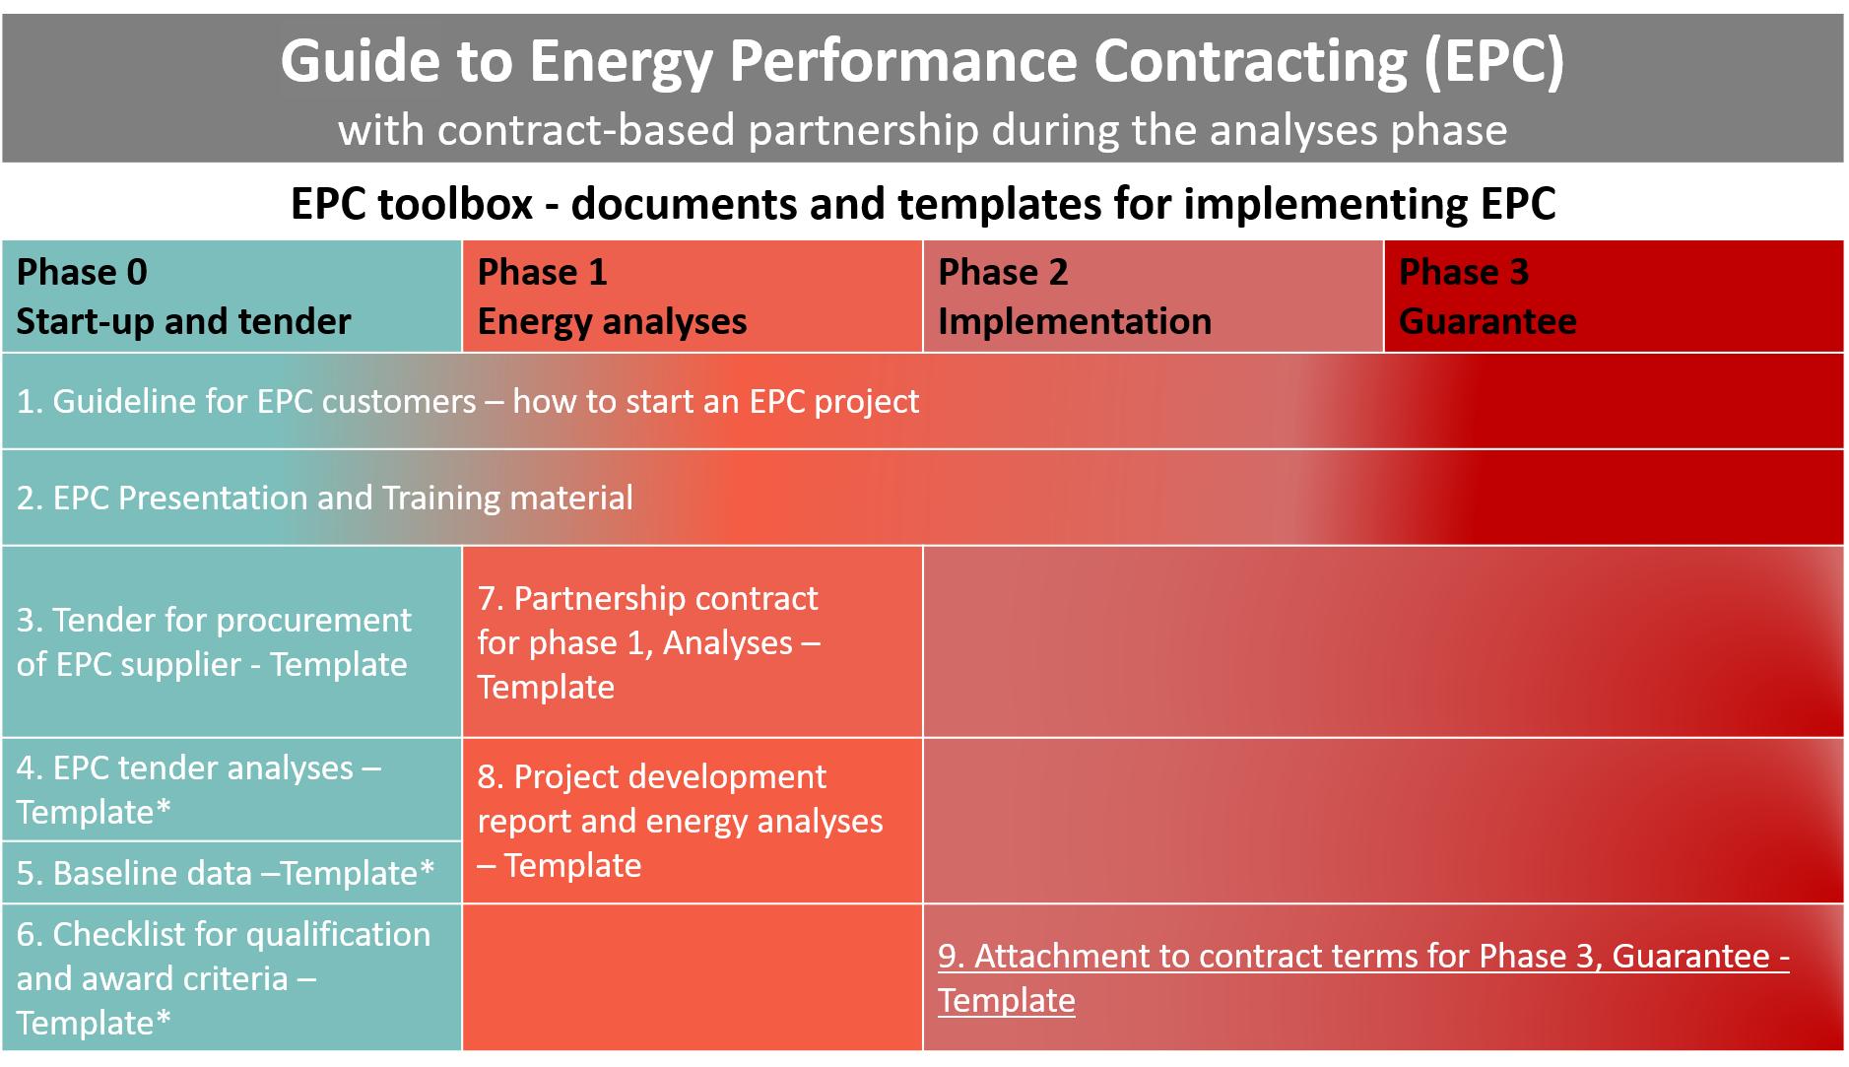
*Not considerably altered compared to traditional EPC implementation model documents

How to use the template
- Please note the disclaimer.
- This template is part of EPC offer/bid and should be filled in by the EPC supplier/ESCO/bidder and submitted as an attachment to offer.
- In the table below the tenderer/bidder should state where the client will find the documentation in the EPC offer.
- In the margins you might find important information to users with background information and advice on what sections should be thoroughly checked and adapted to national laws, regulations, and specific project conditions.
- Please make sure all introductory text, texts in the margins and logos and layout are deleted before launching it as an attachment to the EPC tender.
EFFECT4buildings project is implemented with the support from the EU funding Programme Interreg Baltic Sea Region (European Regional Development Fund) and Norwegian national funding. The aim of the project is to improve the capacity of public building managers in the Baltic Sea Region by providing them a comprehensive decision-making support toolbox with a set of financial instruments to unlock the investments and lower the risks of implementing energy efficiency measures in buildings owned by public stakeholders. More information: http://www.effect4buildings.se/
Partners
THE TENDER'S

Attachment X

CONTRACT TERMS Phase 1
Analyses Phase

PARTNERSHIP ENTERPRISE PHASE 1
Based on
[national standard for turnkey enterprise]

Disclaimer:
Always ensure compliance with the country's procurement laws. Although this document is thoroughly elaborated, it should be adapted to national laws and regulations and verified by national legal counsel / lawyer in each country before launching the tender. This document is a template that must be adapted to each project, so that the customer's goals and expectations for the project are best taken care of.

Table of content
1 THE PARTIES AND THEIR REPRESENTATIVES 3
2 CONTRACT DOCUMENTS AND INTERPRETATION RULES 3
3 PROJECT STRUCTURE (phase 1, 2, 3) 4
4 OBJECTIVES AND POSITIONS OF THE ANALYSES PHASE 4
5 ORGANISATION 5
6 WORK, PROCESS AND DELIVERY IN THE ANALYSES PHASE 7
7 COMPENSATION 10
8 THE RIGHT TO USE THE PROJECT MATERIAL 10
9 AVSLUTNINGEN AV FASE 1 ANALYSEFASEN 10
10 DECLARATION OF CONSENT 11
11 SIGNATURES 11

THE PARTIES AND THEIR REPRESENTATIVES
Building owner
Name: |  | Organisation number:
Address:
Representative: | Phone: | E-mail:

Energy contractor/ESCO
Name: |  | Organisation number:
Address:
Representative: | Phone: | E-mail:

CONTRACT DOCUMENTS
The following documents are included as part of this contract:
1. This Contract Document with attachments
2. Minutes from contract meetings xx.xx.xxxx
3. The energy contractor's offer of xx.xx.xxxx
4. Answers to questions during the tender phase announced in the Tender documentation
5. The tender documents and attachments
6. NS6430:2014 official standard for EPC [national contract terms for turnkey enterprise]

If conflicting content the above ranking of the documents applies.

PROJECT STRUCTURE (phase 1, 2, 3)
The project is divided into three phases with 3 sub-contracts:
- Phase 1: The analysis phase in which the parties will develop a project development report in mutual interaction (this agreement and [national standard])
- Phase 2: The implementation phase is a turnkey contract ([national standard])
- Phase 3: Savings Guarantee Phase ([national standard])

The analysis phase will result in a complete project development report, with a unified fixed price and completion deadline for completion of the project. The building owner chooses which measures to be implemented. Thereafter, an agreement on execution and subsequent guarantee for these measures is concluded (phases 2 and 3). Phase 2 and 3 are initiated if the building owner triggers this option.
This agreement gives the contractor/ESCO the right and obligation to carry out phase 1 The analysis phase and a duty to carry out the other two phases to the extent the customer/building owner wishes.
The energy contractor has the responsibility for the project through the whole duration of the assignment, in all 3 phases.

OBJECTIVES AND POSITIONS OF THE ANALYSES PHASE

Objectives of the agreement
The parties agree that the following objectives and attitudes shall apply to the analysis phase:
- To carry out an efficient and evolving process that ensures fulfillment of the determined energy savings and other quality, educational, financial and timely conditions set out in this agreement and accompanying documents:

- To follow up on the goals, frameworks and rules of cooperation will be set for the parties jointly, as stated in the tender documents.

- To actively contribute to a positive, constructive and solution-oriented working relation for all parties involved and similar relationships with all stakeholders.

- To carry out ongoing evaluations and transfer of experience for continuous improvement of process and product.

- To develop a processed project development report/plan in accordance with the prerequisite of the tender and changes agreed in the interaction phase.

It is crucial for the implementation of the project that the parties' cooperation and interaction is based on the values ​​of honesty, respect, trust and full transparency.

The parties' objective is to:
- Achieve better profitability through optimization of design and execution.
- Identify and develop profitable energy-saving measures that do not detract from indoor climate requirements ([cf. Environmental Health Protection and the [National] Labor Inspection Authority's Guidelines XXX])
- Identify and develop measures that improve indoor climate and reduce climate emissions.
- Ensure that the project is realized in a way that gives both parties a good financial result.
- (Other if applicable)

Transparency requirements
The open book principle is used for phase 1, the analysis phase. This means that all relevant documents from the energy contractor and all subcontractors, advisors and suppliers are available to the building owners' representatives during this phase. The building owner's documentation and underlying decision supporting documents are available to the energy contractor's representatives.

ORGANISATION

General terms
The project organization will consist of the following project bodies:
- The building owner's project organization
- The contractor's project organization during the analysis phase
- (other if applicable)

The detailed composition of the groups can be found in sections 5.2 and 5.3.

The building owners project organisation
The building owner's project organization consists of the following actors:
Function | Name | E-mail | Phone
Project owner
Project leader analyses phase
Representative for property/operation
(Ev. Expert areas and/or resources)

The energy contractor's project organization during the analysis, phase 1
The contractor's project organization consists of the following actors:
Function | Name
Project leader
Responsible electrical engineering
Responsible HVAC engineering
Responsible energy monitoring systems (EMS)
Responsible training and information
Responsible automation
Coordinator of Integrated technical building installations (ITBI-coordinator)
Other

The energy contractor cannot replace persons who were evaluated in connection with the award of the contract or agreed as compensation for such a person without the written consent of the building owner. These can only be replaced by personnel who have at least equivalent experience in the corresponding field. The building owner can only refuse consent if he has factual reason. The building owner shall respond within a reasonable time after he has received a request for consent.

Suppliers and subcontractors
The energy contractor will use the following contractors (subcontractors / suppliers) in phase 1:
Company name | Function | Responsible professional

The management team in the analysis phase
The overall body for development of the project development report/plan is the parties' partnership organization, hereinafter called the management team. This consists of the following actors:
- The client's project owner
- The client's project manager during the analysis phase
- Client's property / operations representative
- The energy contractor's project manager

The leader of the management team is the project's project manager. Players other than those in the management team are included as and when needed.
The management team is presented with proposals for measures and solutions and makes decisions continuously in order to achieve a good process regarding the development of the project. If there is disagreement about the development of the project, the project owner's project owner decides which solutions to choose.

WORK, PROCESS AND DELIVERY IN THE ANALYSES PHASE

Start-up meeting/-gathering
Phase 1 is started by holding a start-up meeting / meeting in which the entire project organization, cf. section 5, participates. The purpose of the meeting is to
- ensure that everyone knows and supports the framework for the collaboration/partnership
- reconciling each other's expectations
- develop common objectives for the project

An evaluation meeting should be held at the end of Phase 1 to ensure that the parties have a common understanding of the project's content and objectives for Phase 2.

Time consumption / meeting activities in the analyses phase
In the remuneration, cf. item 7, the following meetings, including hourly expenses, travel expenses and other costs should be included in the contractor's contribution:
- Management Meeting: Each month and as needed.
- Partnership meetings / design meetings where the developer, the design group and the energy contractor participate: Every 14 days.
- Meetings for evaluation of the collaboration / partnership: Every month
- Special meetings as needed.
- Participation in necessary meetings in political and administrative management with the building owner.
- Cost of a WEB project hotel suitable for interaction in the Phase 1 analysis phase.

A meeting and progress plan will be prepared, which will be part of this agreement. The progress plan will include a deadline for delivery of a complete and final proposal for a project development plan, cf. section 9.2.

The parties' contribution

The building owner's contribution:
- Set requirements for the project where necessary, including, inter alia: performance requirements for technical installations, indoor climate, usability and qualities
- Provide baseline in the form of a completed basic data form and all relevant available information and project material for the project, as well as operational experiences
- Suggest measures to be considered in the individual buildings
- Make necessary decisions to the extent that this is not lifted to the management team

The energy contractor's contribution:
- As soon as possible after the conclusion of the contract, the energy contractor shall submit detailed calculations of the measures offered. The calculation must be at [account level 2 in accordance with [national turnkey standards/regulations] and 2-digit building part number acc. [national turnkey standard]. The calculation must show full cost. Full costs shall only include the contractor's actual costs, whether these are costs for own employees or purchasing costs from the supplier or subcontractor.
- The contractor's mark-up is shown in the price form.
- Create a WEB hotel suitable for interaction in the Phase 1 analysis phase.
- Suggest measures based on the calculation and savings at the same level/quality as used in the tender analysis. For each measure, the contract price, payback time and a guaranteed energy saving in €, kWh and kW are listed.
- Prepare the project development report and energy efficiency analyzes with selected qualities and savings
- Project Optimization
- Engineering
- Engineering Management
- Calculations
- Progress Planning
- Technical calculations and analyses

Duties of both parties:
- Inspection/survey of the building stock with subsequent review of relevant measures and selection of measures to be investigated by the energy contractor.
- Establish project teams and hold meetings and possible workshops
- Establish project organization
- Formulate and accept project objectives
- Establish risk and assumptions
- Ensure that environmental and work environment considerations are incorporated into the project
- Prepare and develop phase 1 The analysis phase in partnership
- Prepare a contract for phase 3, where all conditions and risks are highlighted

Delivery phase 1
Complete and final pre-project / project development plan shall consist of:
- Unified project development plan/report and energy-efficiency analysis
- Technical solutions for all technical subjects and associated drawings including necessary reports, calculations and other relevant documentation
- Pre-project calculation for phase 2, implementation phase
- Plan for technical final implementation, phase 2
- Appendix for contract phase 3 with, among other things, operating conditions
- Progress plan for phases 2 and 3
- Other

In addition, the energy contractor and the building owner will agree on the scope and price of the relevant service agreements.

Changes in the analysis phase – impact on the contract sum phase 2
It must be expected that major changes can be made to the project during the analysis phase, such as increasing or reducing the project's scope, area, completion time / phase for implementation, etc. Such changes are a prerequisite for procurement. The energy contractor cannot claim changes in hourly rates, mark-up percentages or unit prices for phase 2 as a result of such changes regardless of the volume of the changes collectively and individually.

The price elements for phases 2 and 3 are indexed in accordance with the provisions of Appendix X (form X for phases 2 and 3, [national standard/regulations]).

Conflict resolution
The partnership agreement is based on an alternative conflict resolution model where the aim is to resolve disputes quickly at the lowest possible level in the organizations. The client's project manager and the energy contractor's project manager shall make decisions within the project organization.
Disagreements related to interpretation of offers and other contractual matters are lifted to the management team for decision and should normally be resolved within one week.
If agreement is not reached within the management team, the conflict shall be handled by the conflict council, which consists of project owner with the building owner and contract owner with the energy contractor.
If an agreement is not reached within the conflict council, the general dispute resolution rules in [national standards/regulations] shall apply.

COMPENSATION

Payment
Compensation for carrying out the analysis phase is NOK [xxx xxx or x EUR / m2]. Payment can be reduced/increased if the number of m² changes. The fee for the Phase 1 analysis phase is paid when the project development plan is approved by both parties.
The remuneration does not need to be price-index adjusted.

THE RIGHT TO USE THE PROJECT MATERIAL
This item replaces section [X.X.X in national standard/regulations].
The building owner acquires ownership and full right of disposal of all paper-based and electronically stored material as it is produced under this contract, and the right to use such material in contract with someone other than the energy contractor.
The building owner shall, irrespective of the organizational form of the project in question, have ownership and all rights to all work done in and in connection with the assignment, also with regard to all data contained in the project hotel (including calculations, simulations, databases, object library), management, operation and maintenance (MOM) documentation and other deliverables developed and provided by the engineer and contractors / suppliers.
Where material is required to be exported and delivered in standardized formats such as. IFC, the same material must also be delivered in original format.
The contracting parties shall ensure that the contractor's rights related to the contract are continued and secured in agreements with subcontractors and suppliers.

THE END OF PHASE 1 – THE ANALYSIS PHASE

Duration of the analysis phase
Phase 1 The analysis phase starts on dd.mm.20yy and ends with an approved preliminary project.
See time schedule for the project in the tender document.

End of the analysis phase
After the building owner has received the final proposal for the project development plan and energy efficiency analysis from the contractor, the proposal will be reviewed and evaluated to decide whether to proceed with the project.
If the building owner finds that it is necessary to make corrections or changes in the proposal, this can be sent back to the contractor and the partnership group for further processing before the necessary decision under section 9.1 can be made.

DECLARATION OF CONSENT
By signing this agreement, the consent is given that the developer can process personal information that is necessary for the execution of the project.
Among the information being processed is the contact information of the contact person at the building owner, including name, address, e-mail address and telephone number.
The consent is voluntary, and may be withdrawn at any time, by emailing the building owner's representative, or through the procedure described in the Client's Privacy Statement.
For more information on the processing of personal data and the rights that apply, see here: [rights and duties as directed by national data protection and personal privacy laws - link to relevant websites]

SIGNATURES
This agreement document is drawn up in duplicate, one for each of the parties.
DatE: | Place: | Date: | Place:
The building owner's signature |  | The energy contractor's signature
____________________________  Name  Position |  | __________________________  Name  Position

