Checklists for answered qualification and award criteria
Template

EFFECT4buildings Toolbox:
Energy Performance Contracting; Annex 6

The project “Effective Financing Tools for implementing Energy Efficiency in Buildings” (EFFECT4buildings) develops in collaboration with public building managers a comprehensive decision-making support toolbox with a set of financial instruments: Financial calculation tools; Bundling; Funding; Convincing decision makers; Energy Performance Contracting; Multi Service Contracting; Green Lease Contracting; Prosumerism. The tools and instruments chosen by the project has the biggest potential to help building managers to overcome financial barriers, based on nearly 40 interviews with the target group. The project improves these tools through different real cases.
To make sure building managers invest in the best available solutions, more knowledge on different possibilities is needed as well as confirmation from colleagues that the solutions performs well. EFFECT4buildings mapped technological solutions for energy efficiency in buildings with the aim to share knowledge and experiences of energy efficiency solutions among building managers in the Baltic Sea Region.

Energy Performance Contracting (EPC) is a well-tested and successful model for energy saving. It is used by public building owners to reach climate and energy targets at a faster pace than with traditional implementation. There is still a large energy-saving potential in public sector.

This template is a Checklist for answered qualification and award criteria based on the Guide to EPC developed in the framework of the EFFECT4buildigs project. The guide introduces a new implementation model based on experiences in the countries involved in the EFFECT4buildings project - its main novelty aspects being contract based partnership during the analyses phase and new award criteria to better fit the goals of building owners.
The Checklist for answered qualification and award criteria is part of a toolbox of 9 documents and templates adapted to the new implementation models various phases primarily emphasising the first two phases. Experiences from past EPC projects shows that decisions made early are crucial. The goal is to promote EPC as an energy saving model and simplify the start-up of an EPC project.
Below is a schematic overview of the adapted tools and instruments for EPC:
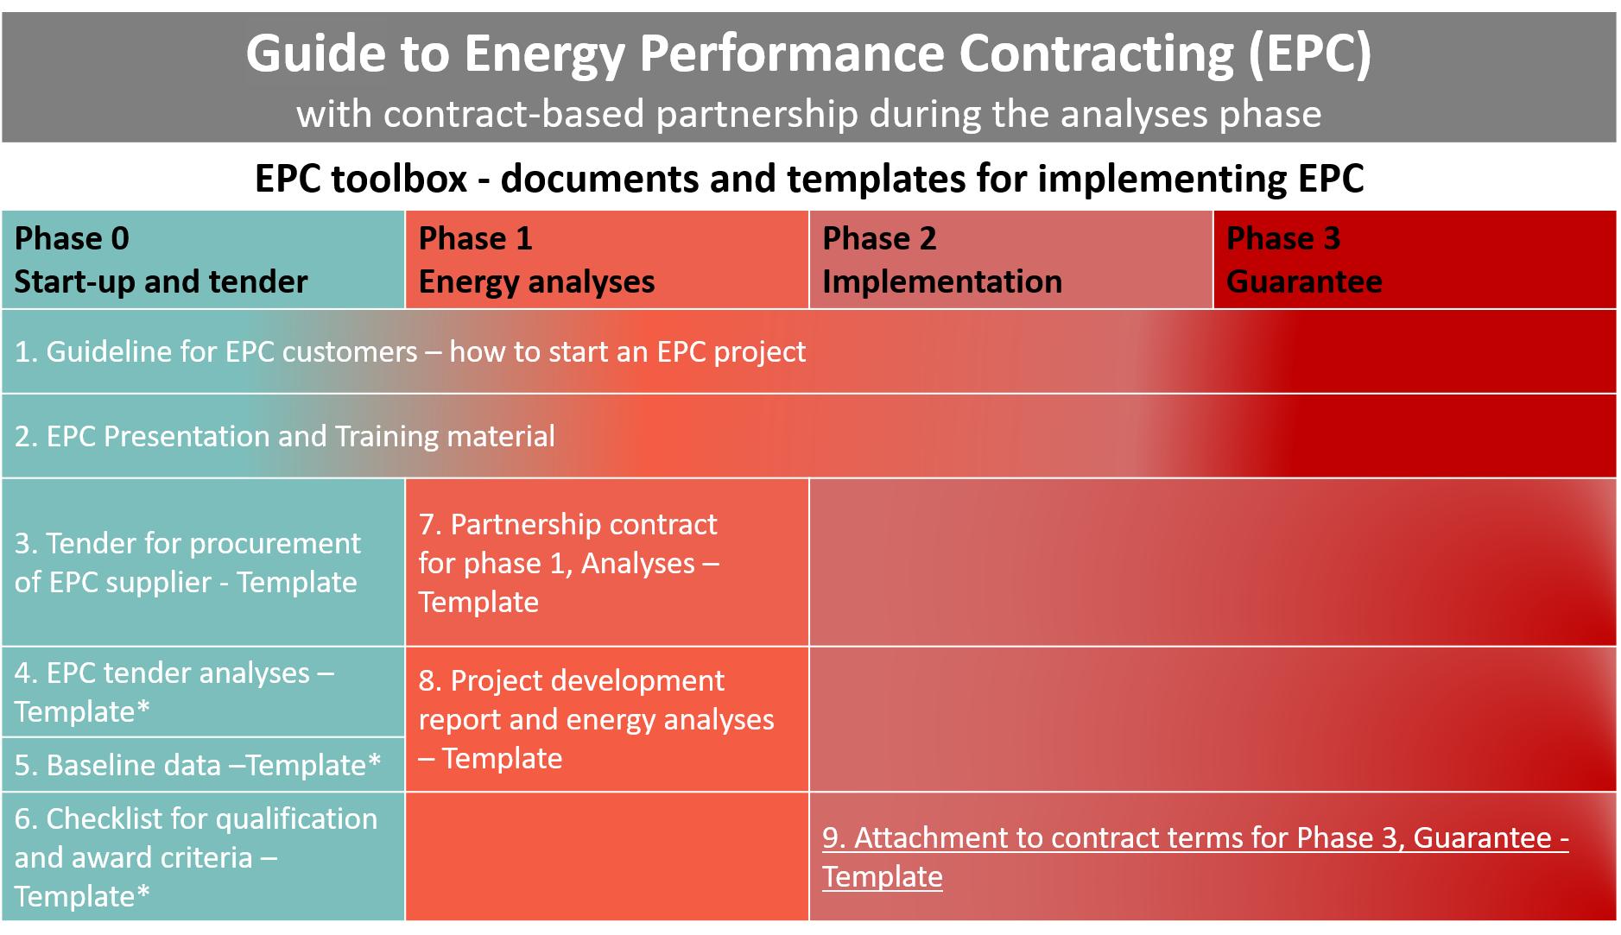
*Not considerably altered compared to traditional EPC implementation model documents

How to use the template
- This template is part of EPC offer/bid and should be filled in by the EPC supplier/ESCO/bidder and submitted as an attachment to offer.
- In the table below the tenderer/bidder should state where the client will find the documentation in the EPC offer.
- In the margins you might find important information to users with background information and advice on what sections should be thoroughly checked and adapted to national laws, regulations, and specific project conditions.
- Please make sure all introductory text, texts in the margins and logos and layout are deleted before launching it as an attachment to the EPC tender.
The EFFECT4buildings project is implemented with the support from the EU funding Programme Interreg Baltic Sea Region (European Regional Development Fund) and Norwegian national funding. The aim of the project is to improve the capacity of public building managers in the Baltic Sea Region by providing them with a comprehensive decision-making support toolbox with a set of financial instruments to unlock the investments and lower the risks of implementing energy efficiency measures in buildings owned by public stakeholders. More information: http://www.effect4buildings.se/
Partners

Checklist for answered qualification and award criteria
This checklist is to be filled in by the EPC supplier/ESCO and submitted as an attachment to the EPC offer.
 |  | State where the client will find documentation in the EPC offer?
Offer letter  - Dated and signed by a person authorized to sign an offer on behalf of the energy contractor.  - If the offer is signed by anyone other than the person (s) who, according to the company certificate, can commit the energy contractor, ask for an explanation / confirmation of it. |  | Fill in
Qualification criteria

- Certificates
 | - Certificate of company registration | Fill in
 | - Tax certificate for value added tax (VAT) (RF-1244, cf.  regulation 4 July 2006 no. 402.) | Fill in
 | - Tax certificate for tax (RF-1244, cf. regulation 4 July 2006 no. 402.) | Fill in
 | - Economic and financial capacity
 | - Credit rating by an approved credit rating agency | Fill in
 | - Technical and professional qualifications
 | - Documented ability for implementation | Fill in
 | - The company's most important deliveries in the last 3 years, including their value | Fill in
 | - Statement regarding the company's quality assurance system / quality management system | Fill in
 | - Confirmation that the offeror is authorized / approved for the work the offer includes | Fill in
 | - Organization plan for the individual phases | Fill in
 | CVs of offered personnel | Fill in

 | Award criteria
 | - Best customer profitability  - Project understanding / knowledge  - Quality  - Energy contractors mark-up [%]  - Other | Fill in  Fill in  Fill in  Fill in  Fill in

Place, date, year |  | Tenderer’s/bidders signature

